k-Nearest Neighbour (KNN) - Supervised

Very simple model without any theoretical reasoning, highly non-linear. Use when your data belongs to non-linear separable classes.

!!! Very often it leads to overfitting.

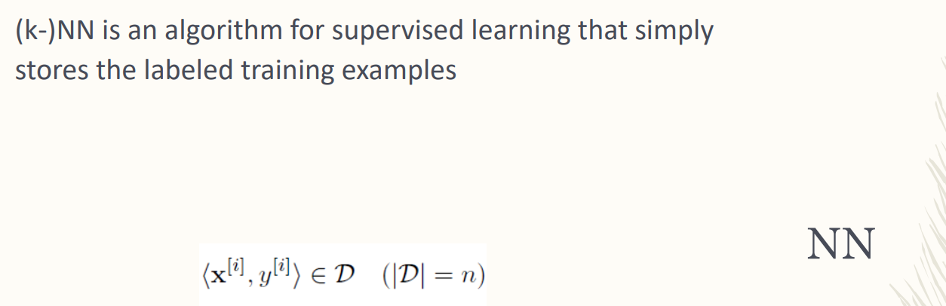

Supervised learning setting

It stores the labeled training examples. Stores the features matrix and the output vector. Stores matrix *X* and output *y*

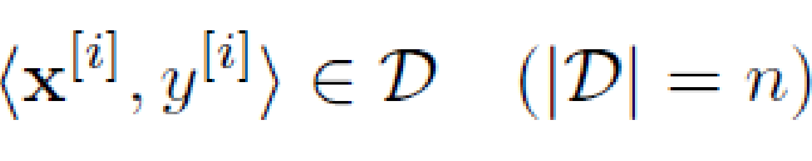

training dataset, for each sample you have vector X with eh features and correct label with the y

D = training Dataset/domain

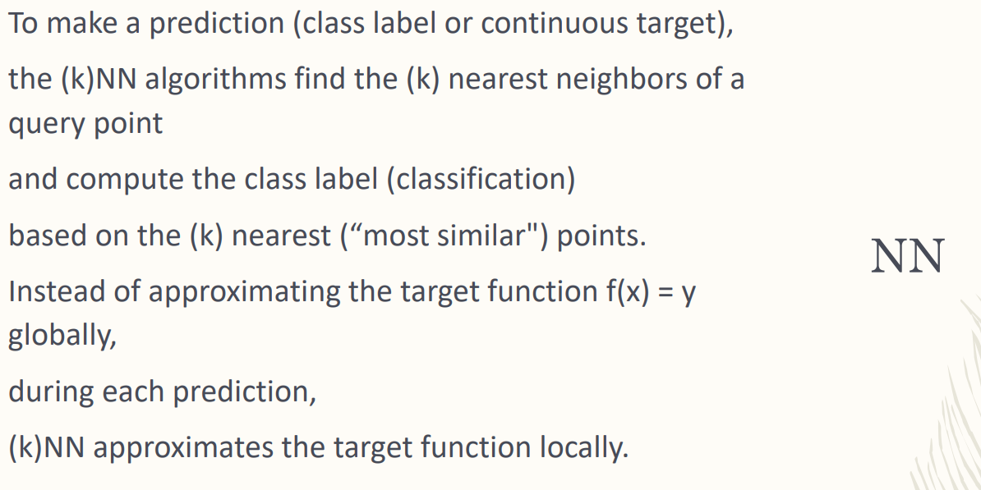

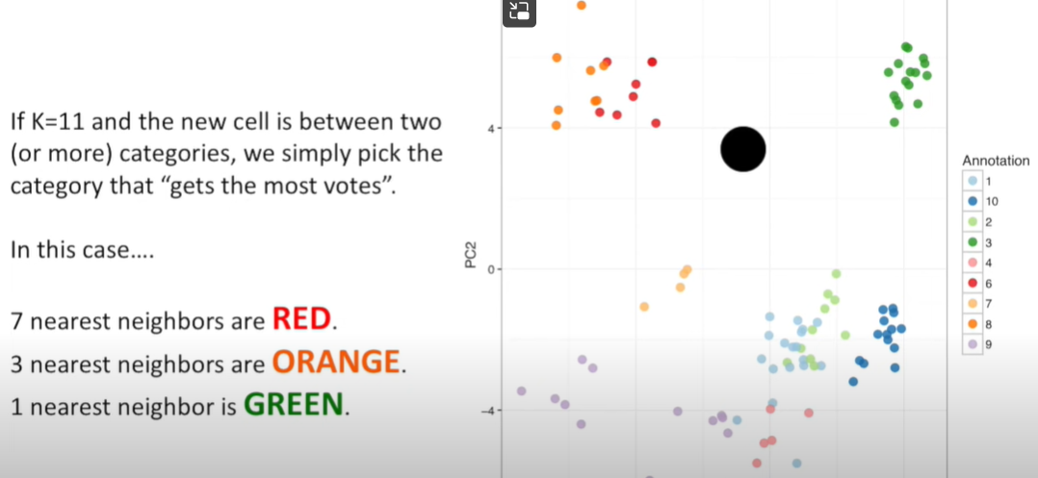

No manipulation of the feature. We don’t need a model.

If two points have similar features you think they belong to the same class. Find the class

We don’t have a model. We are not modeling the ML task as finding the target function f equal to the class label.

Approximate target function locally.

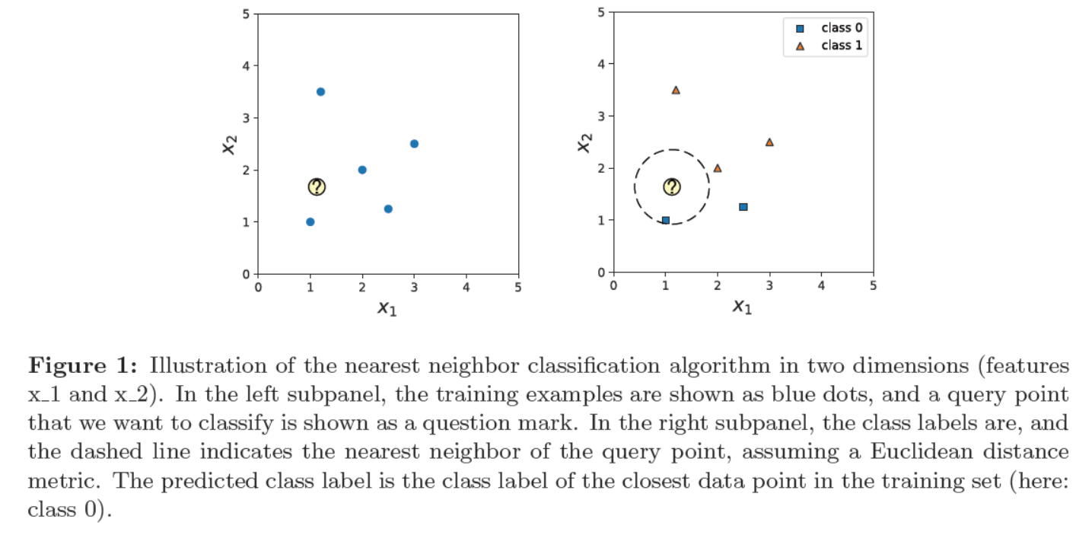

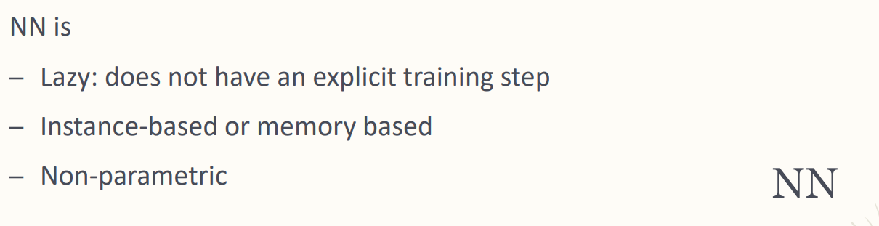

All NN algorithms are lazy (don’t have explicit training step, you don't do training) it is memory base (memorize all the training data and to query the dataset) don’t have a model.

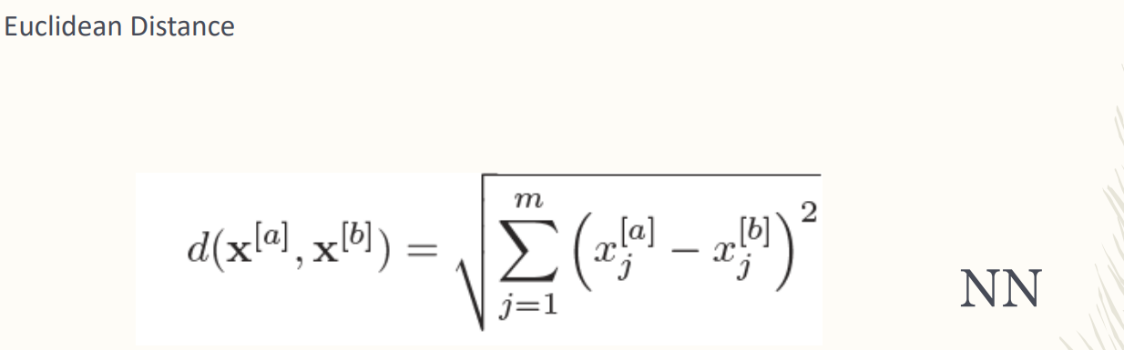

Two point are similar

Similarity measure. Can use different similar measures depending on what you want to find.

Euclidean distance is the most used one.

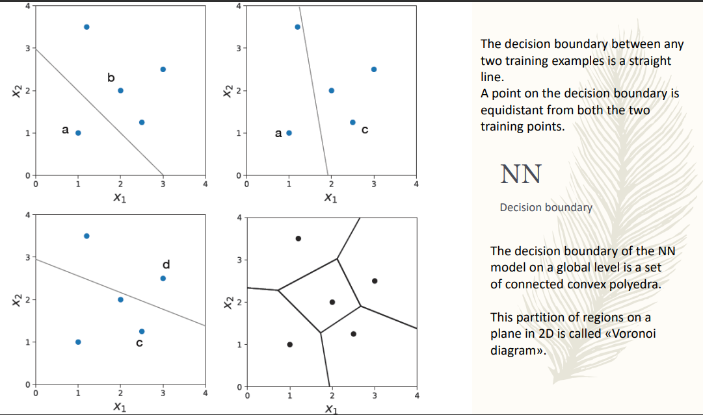

The decision boundary is equidistant from both the two training points.

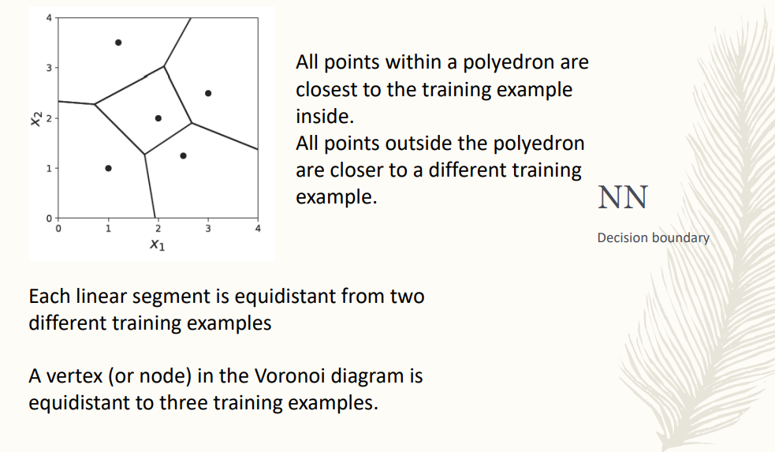

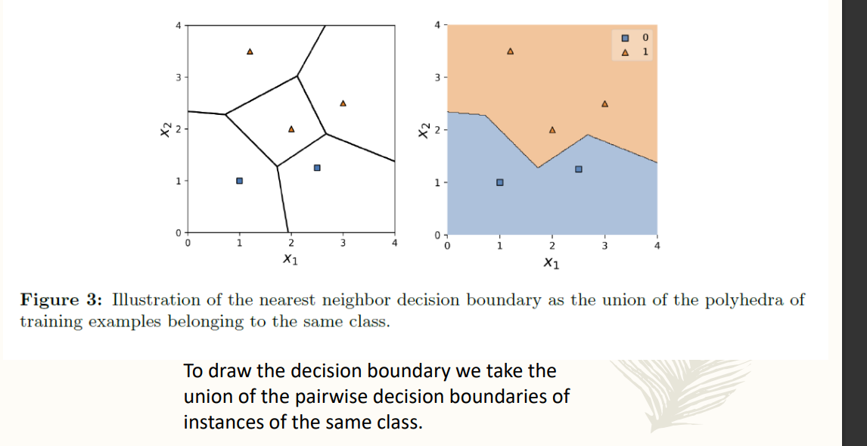

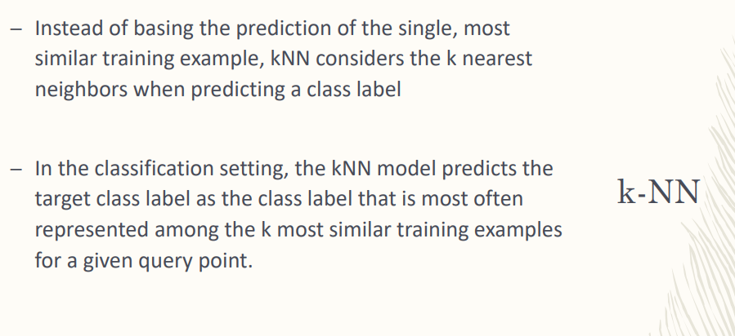

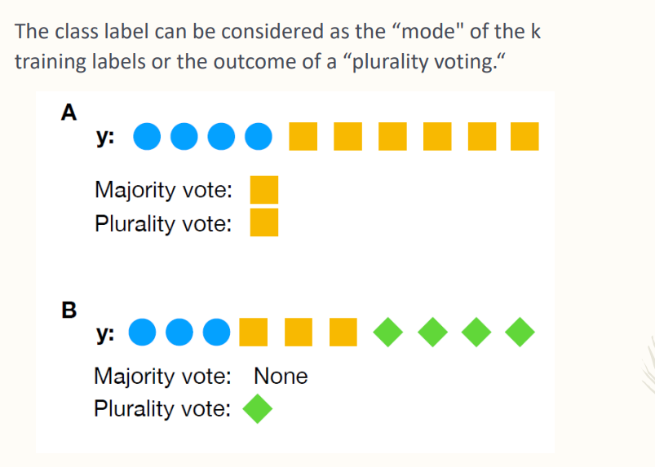

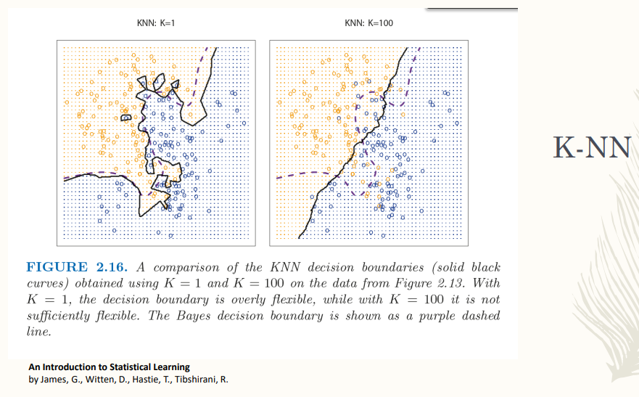

(first image overfitting, second underfitting)

KNN is able to give classification boundaries that are high nonlinear. Complexity equal to the number of points

Overfitting: following all points in the training data. Overfitting because when your model completely follows each dataset means that you are fitting also the noise you have in the data.

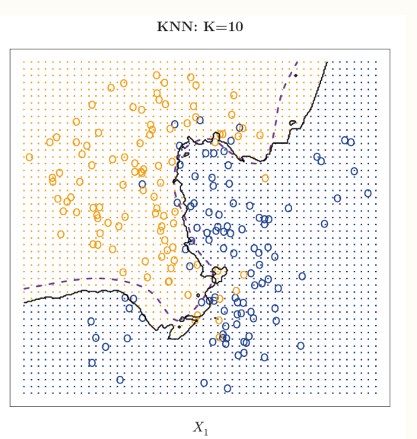

K = 10 able to follow the shape of the two classes without having small sub-areas for each point.

Find the right K. You need to try, no intelligence a priori.

Overfitting real problem of ML

Many parameters ⟹ complex models ⟹ can lead to overfitting problem

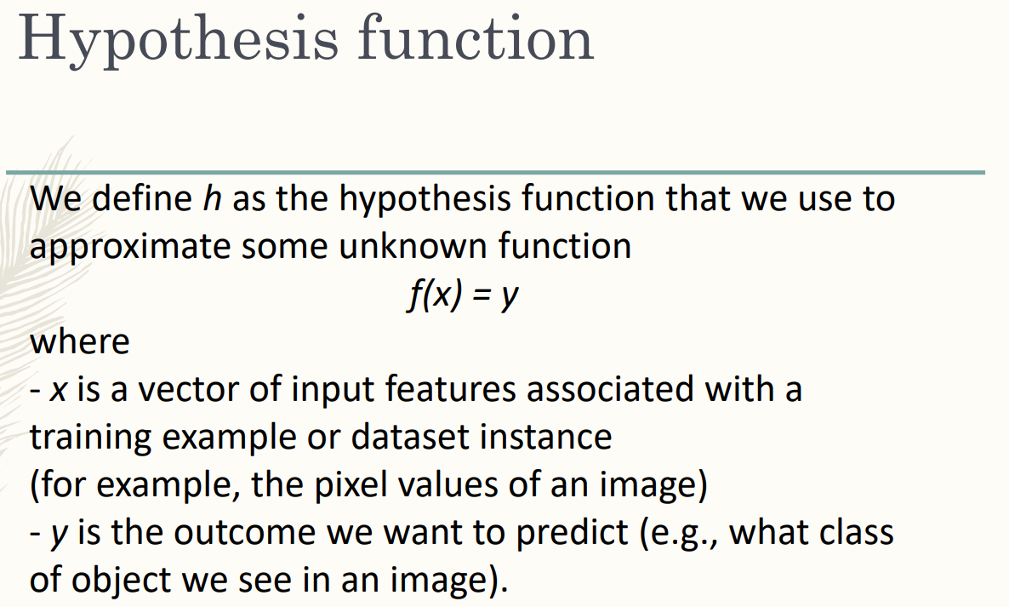

following all points in the training dataset and considering also the noise.

If you have limited training dataset and Deep Learning with many parameters can have overfitting

Prediction task: you obtain a perfect model for Twitter but can not be generalised to another social media. Overfitting is the elephant in the room in the machine community.

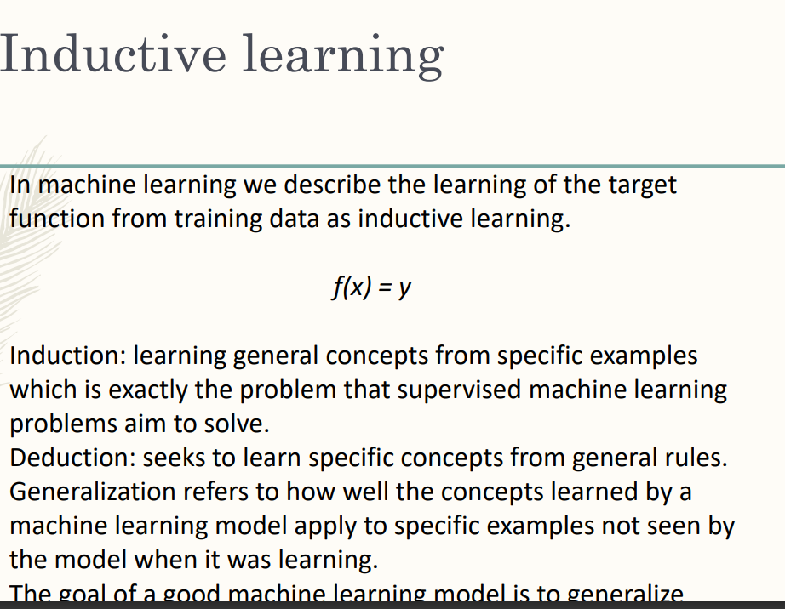

… to data you will see in the future and are not part of the training dataset. Generalisation means I have done all the training phases.

I want to learn general concepts. from specific examples.

The problem is the generalisation of the model.

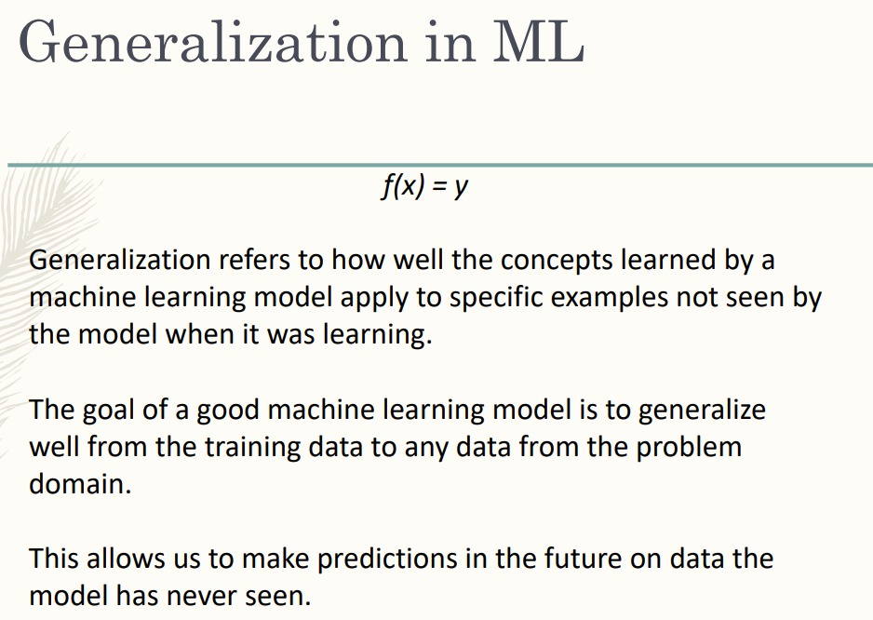

Generalisation refers to the ability of your model. Model + fix parameter learned during the training.

Ability of our model to adapt property to new unseen data taken from the same distribution.

Regularisation can be applied to regression or classification. Helps you using complex model and using them to get something that is not noisy.

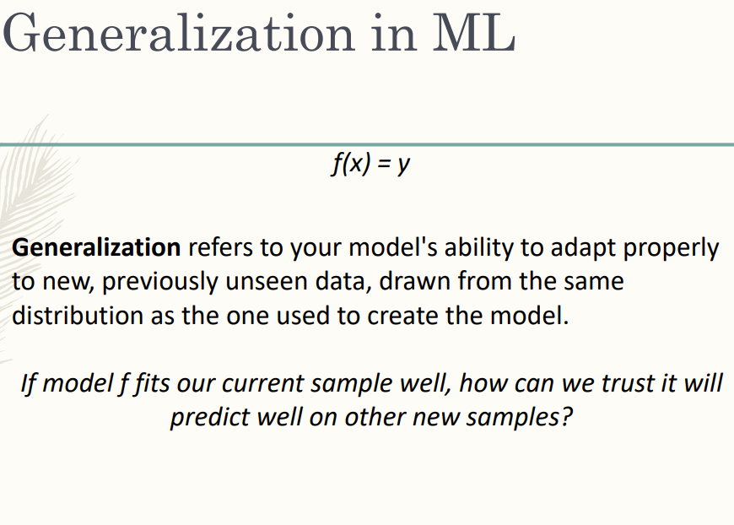

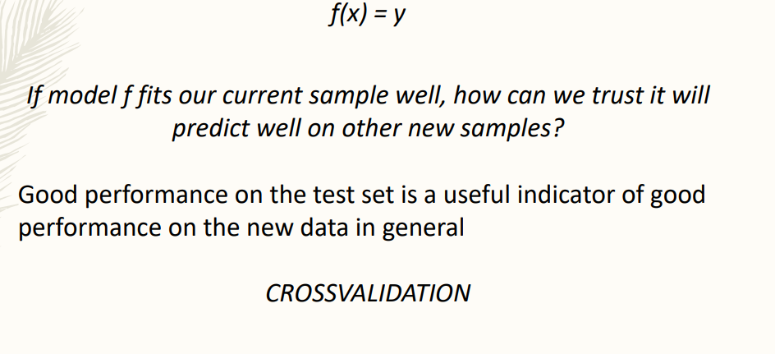

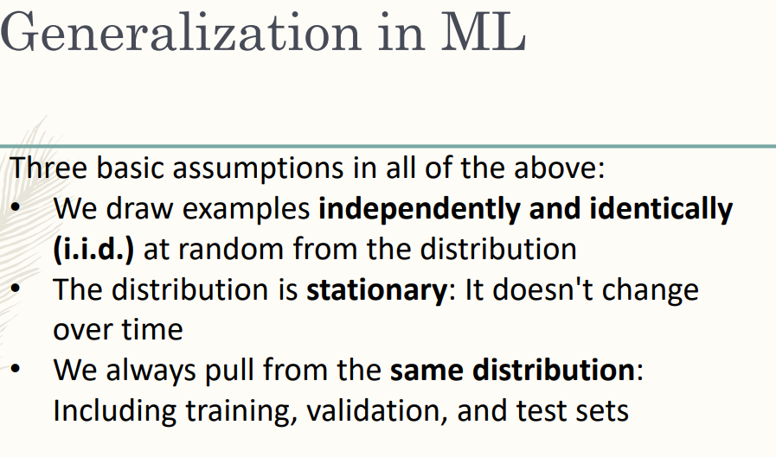

New data have to be drawn from the same distribution of the training sample.

Generalisation is just about new data drawn from the same distribution

Stationarity: new data that you have to classify. If you have this future data, your system has a good stationarity. Have to check that in the future your model does not change.

Example in the training dataset must be independently and identically distributed. data from the sample the data are not independent. you should check correlation between the sample

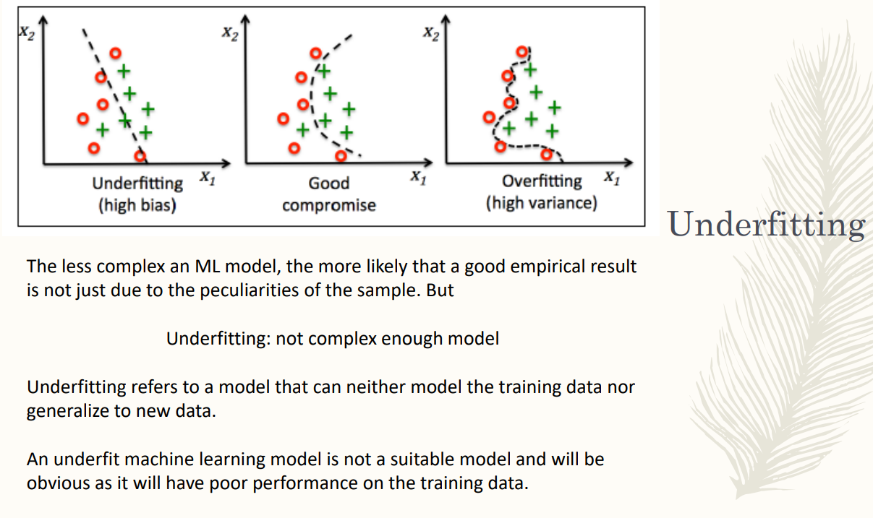

Underfitting: the model is not complex enough. Model which is not able to correctly classify the training sample

overfitting: use complex model to have all the model correctly classified

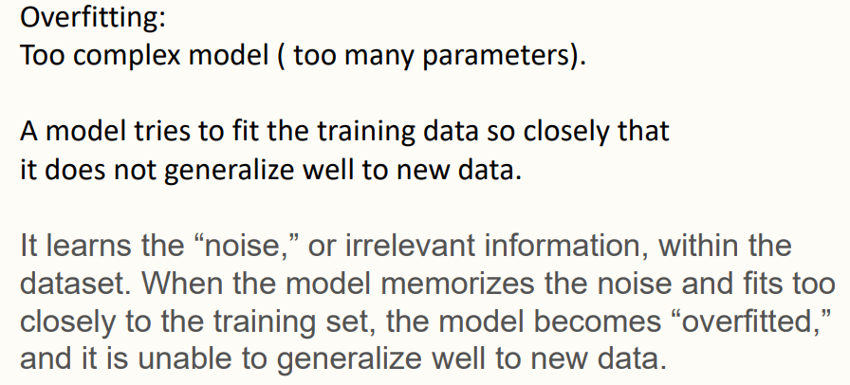

overfitting you memorise the noise and outlier, not able to generalise to new data.

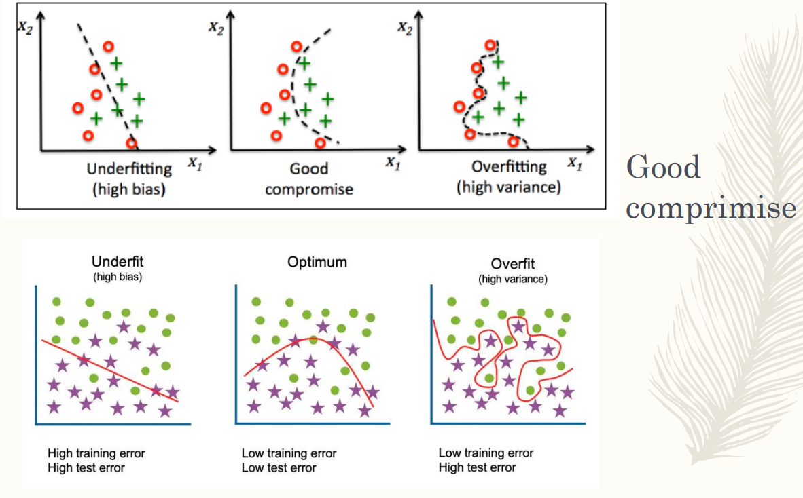

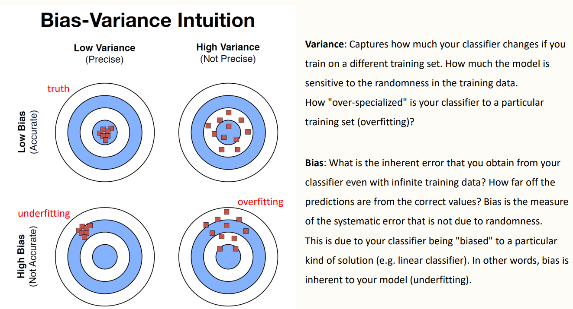

high variance ⟹ overfitting, model is too complex

best model: low bias and low variance

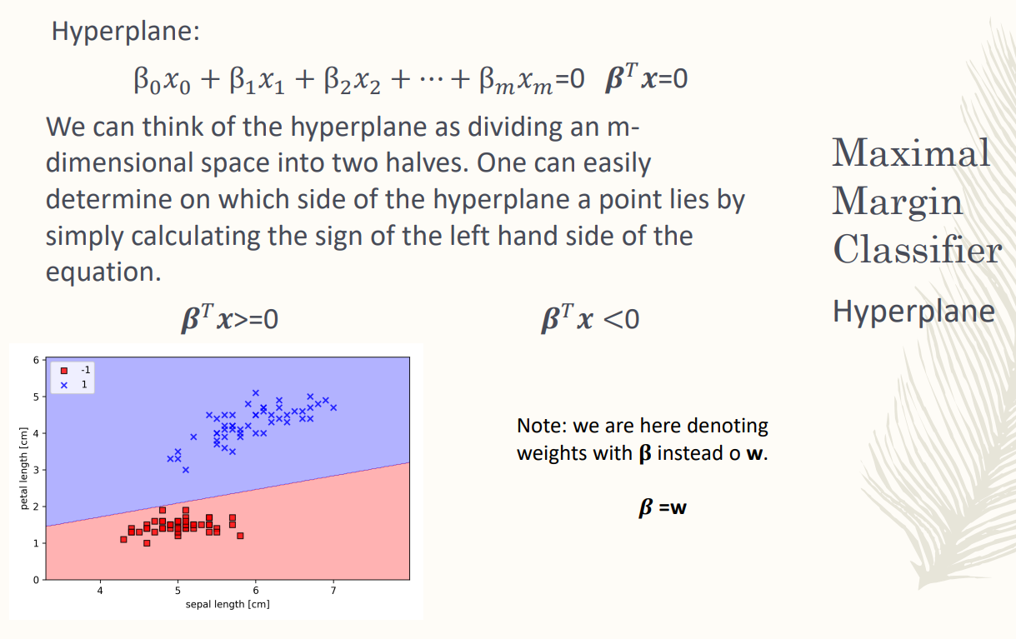

Perceptron, adaline and logistic regression good for linearly and almost linearly

**support vector machine**: learning algorithm models that are not linear

Grant a lot of success on SVM. Model very nice in mathematical view, right now we use deep learning but SVM needs less data, can work with a smaller dataset

Idea of Maximal Margin Classifier (that has inside SVM) is same as perceptron, adeline and logistic regression

Find the hyperline, divide the plane in two parts. [ Do not change the idea of ML problem of logistic regression. (in SVM use β instead of W) ]

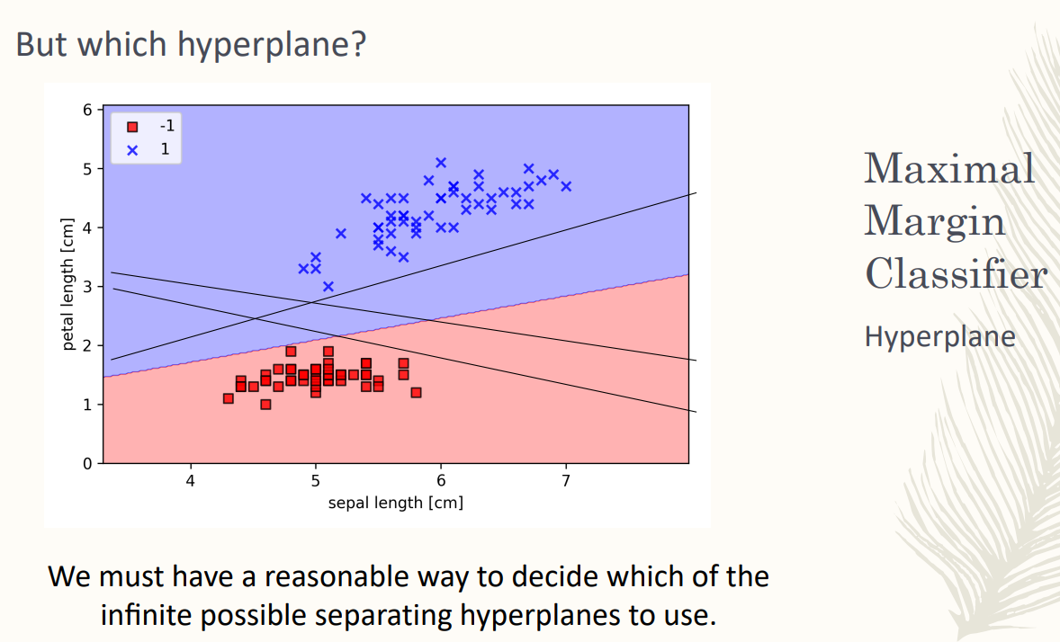

When you have the training dataset you have two sample points belonging to two different classes. Find one of the possible hyperplane dividing the space in 2

But you have more than 1 possible hyperplane (actually they are infinite). When you divide it you will have an infinite amount of hyperplane that correctly divide the dataset

How can we decide which hyperplane is the best one? Before you did not have reasoning about this. Now we can

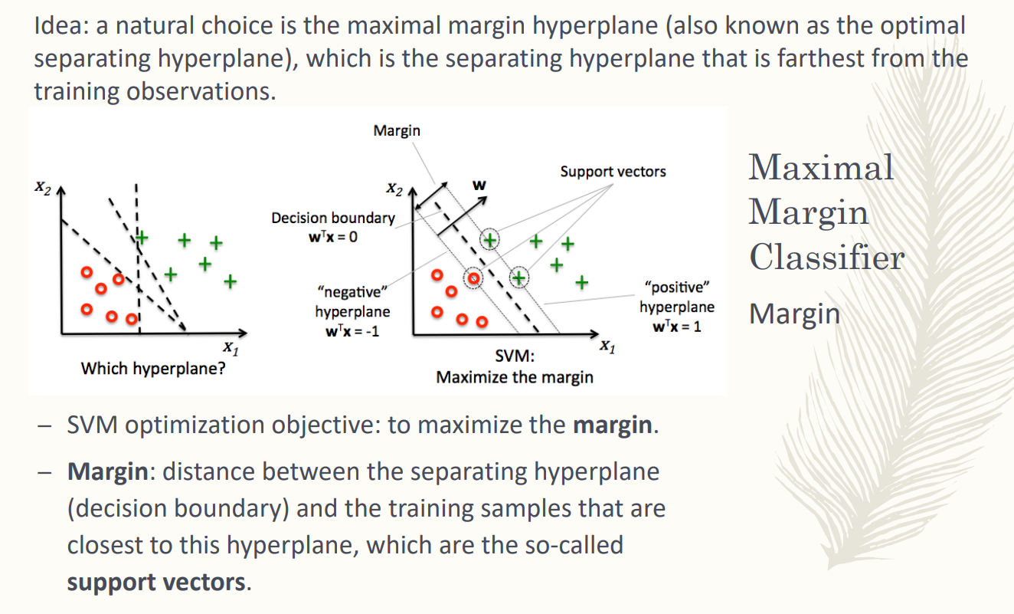

choose the hyperplane that guarantees to be in the middle. the maximal margin hyperplane is that is the farthest from the training observation

the margin is the distance between the best hyperline and the closest training sample.

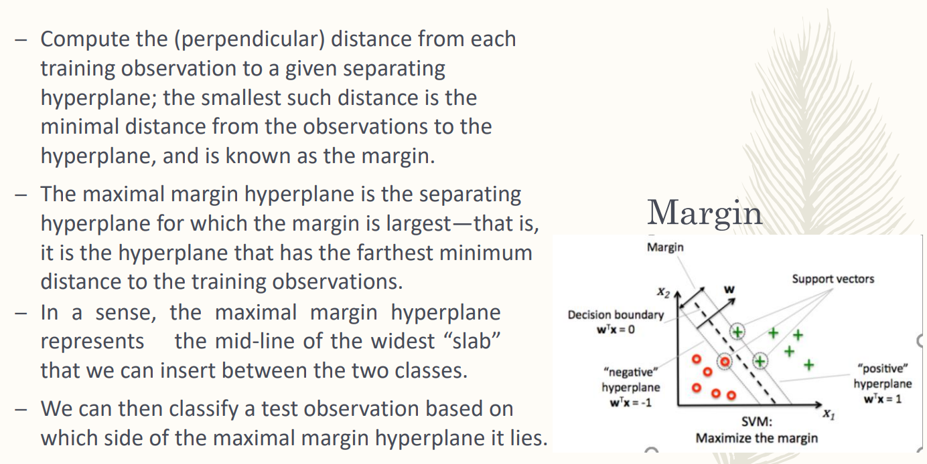

given an hyperlane and the training data we can find the best hyperlane, it is the separating one for which the margin is the largest

once you have found the best one you classify using the same rule

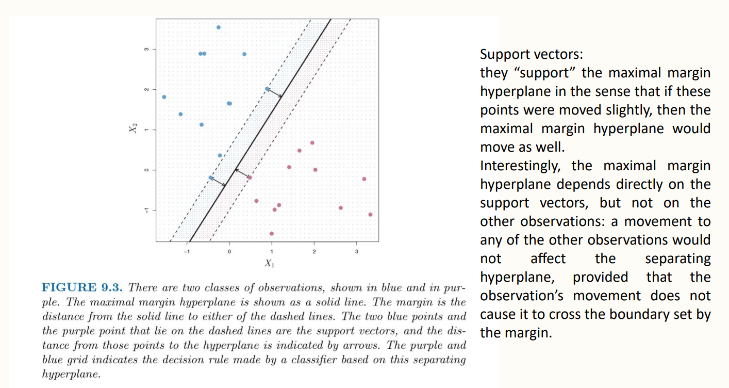

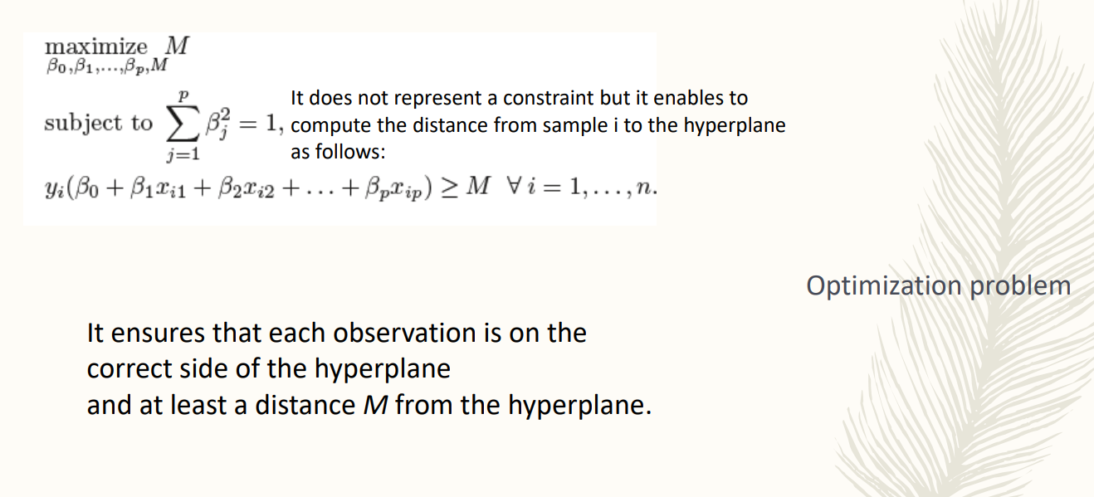

you optimise the margin. Depends also on the parameters..

the sum of the squared of the parameters must be equal to 1. It is not mandatory, but if introduced finding the distance is much more simple

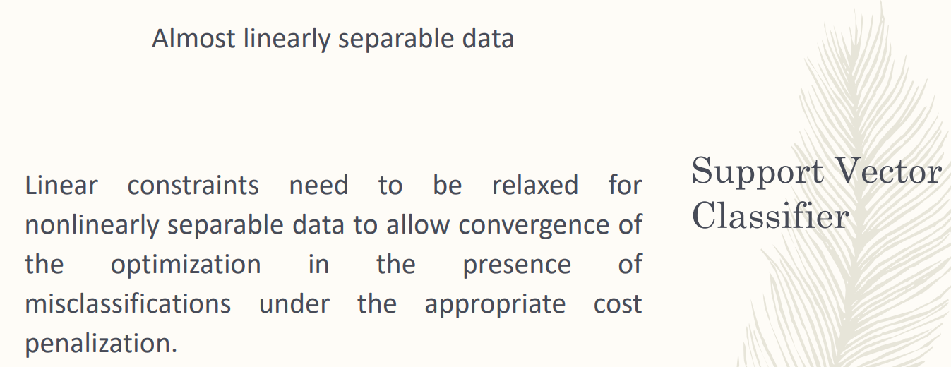

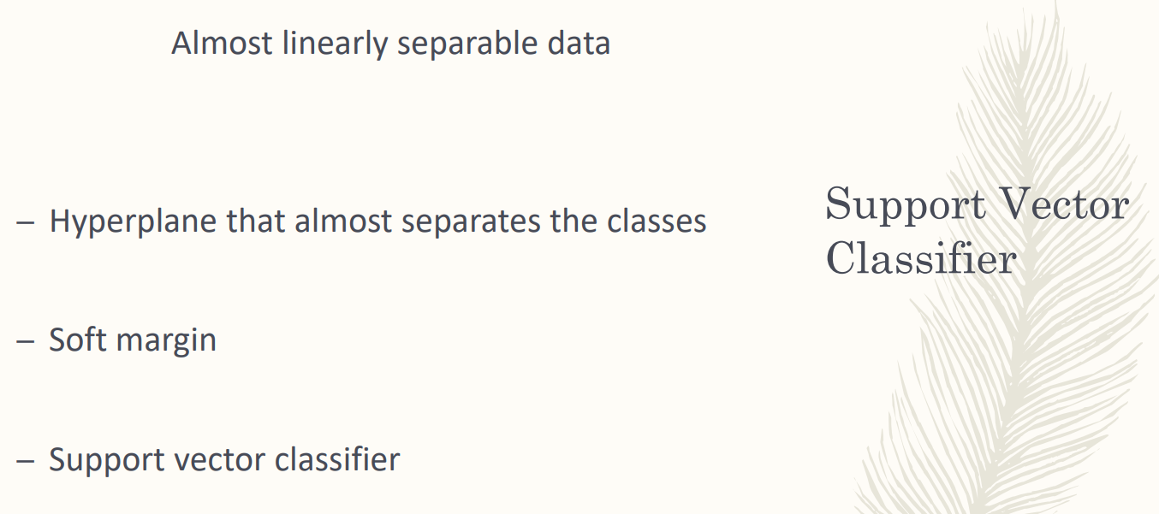

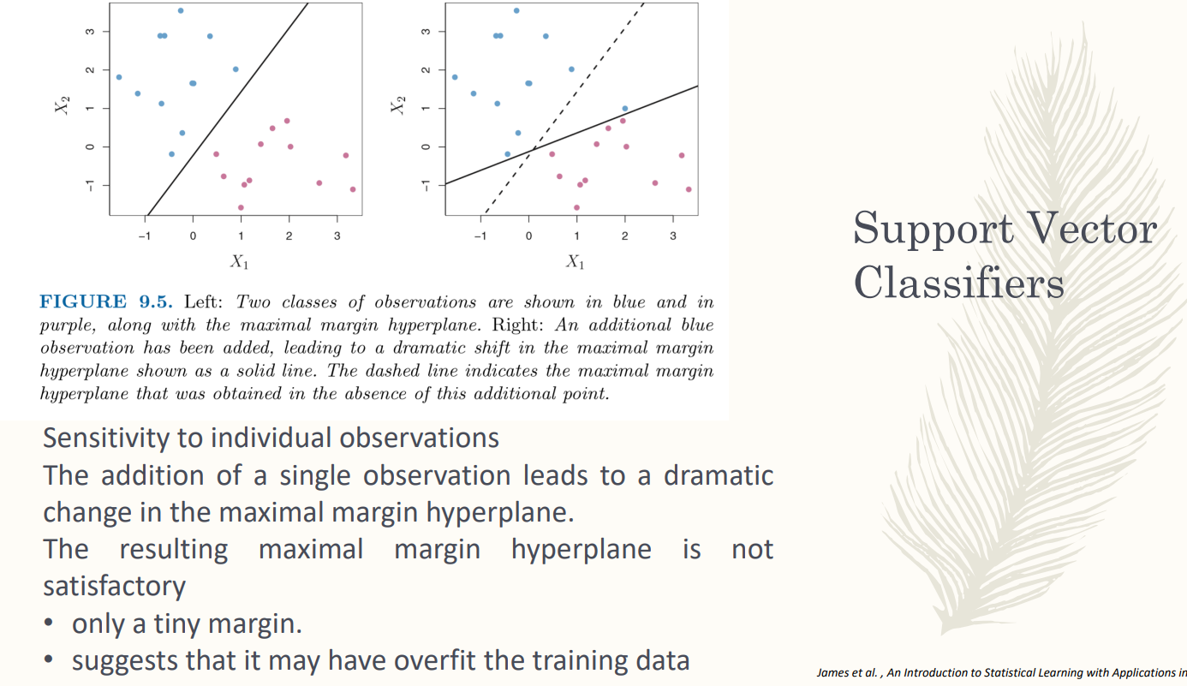

We are allowed to have misclassification

you have to pay attention, in this kind of model you have support vectors (?) can lead to a completely different hyperplane

First image. The maximal margin hyperplane dividing the two classes is the one found. On image 2 if you add another data you have a completely different hyperlane. For the generalisation problem better the first one

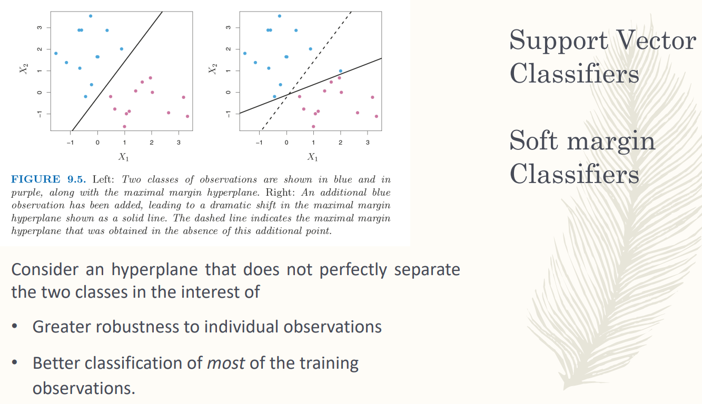

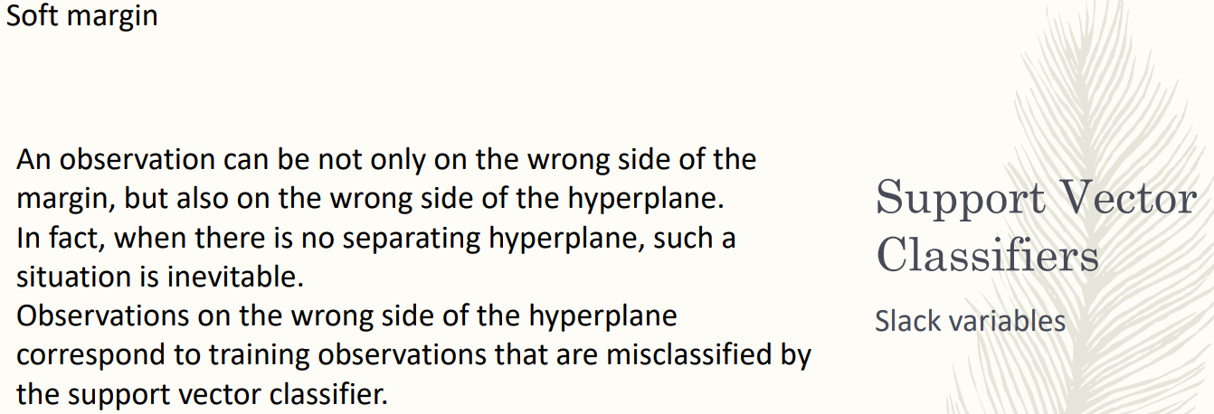

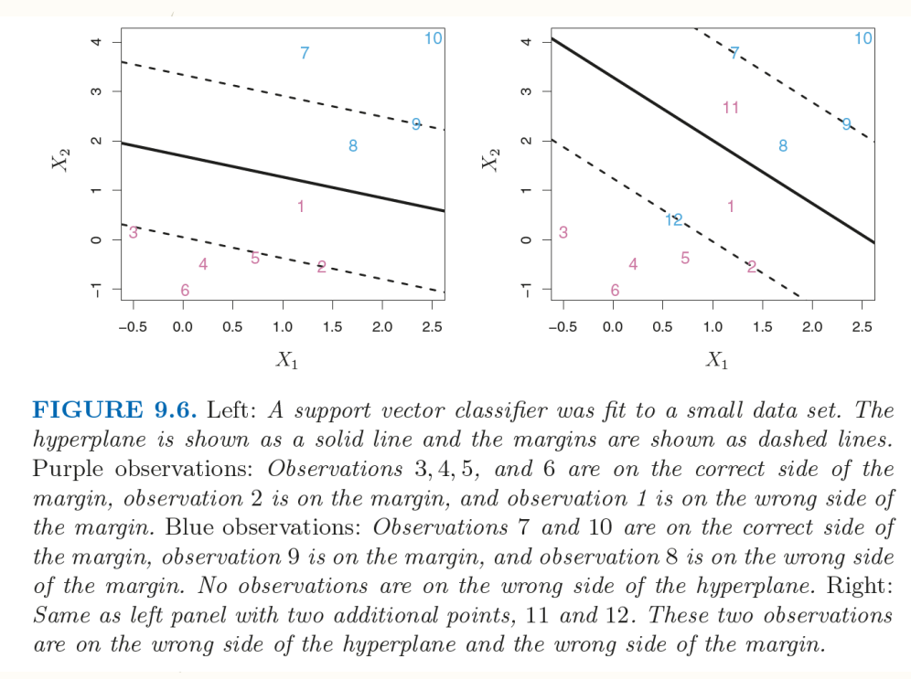

Case of all observations are correctly classified, but by a very broad margin. We allow to have some points inside the margin

image 2 we force the model to have points inside the margin but also misclassification. Point 11 is in the wrong side of the margin but also in the wrong part of the hyperlane

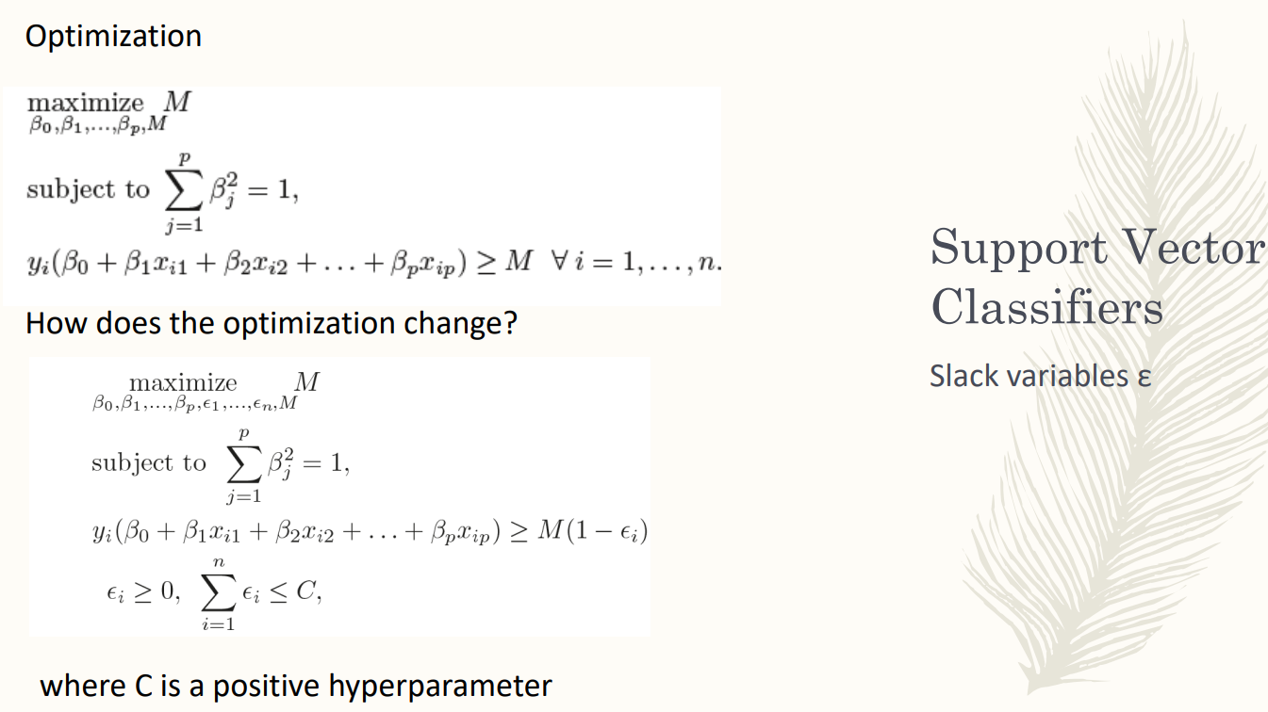

introduce the **slack variable ε**. [ The product between the label of the class is greater then the value of the margin multiplied by a factor ]

The slack variables are positive.

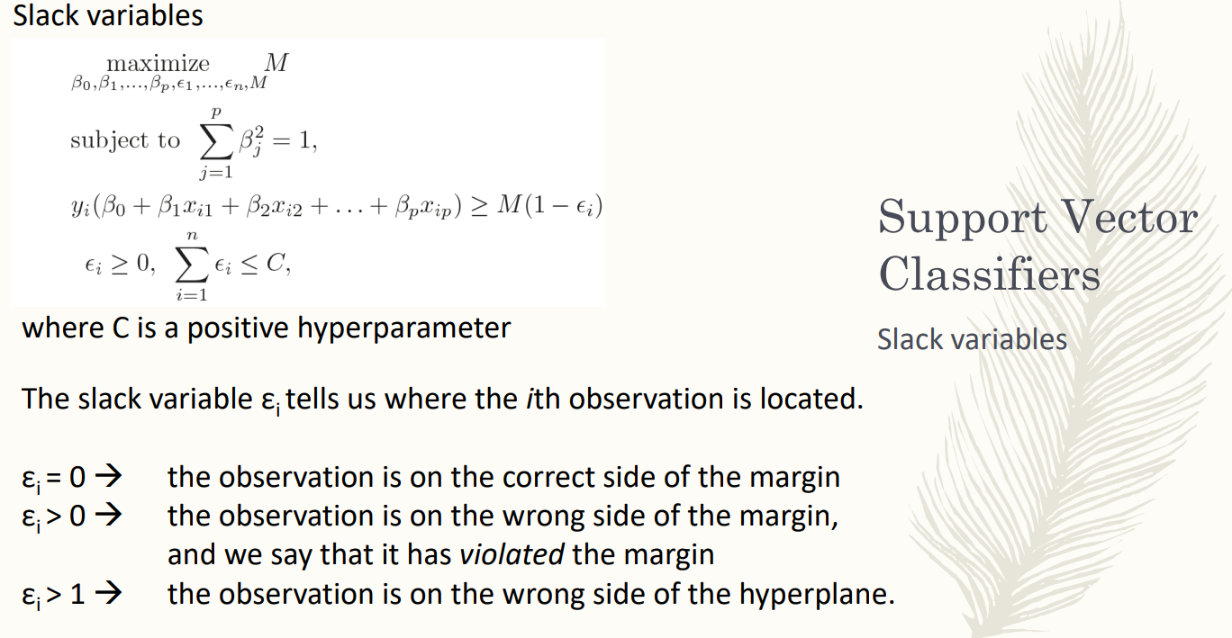

if ε > 0 observation can be in a distance from the hyperplane less than the margin.

ε > 1 we are misclassifying the observation. We obtain that is higher than the negative value.

slack variables allow to have misclassification and observation in the training dataset that violates the margin. We ask that the sum of the slack variable have a bound that is called C

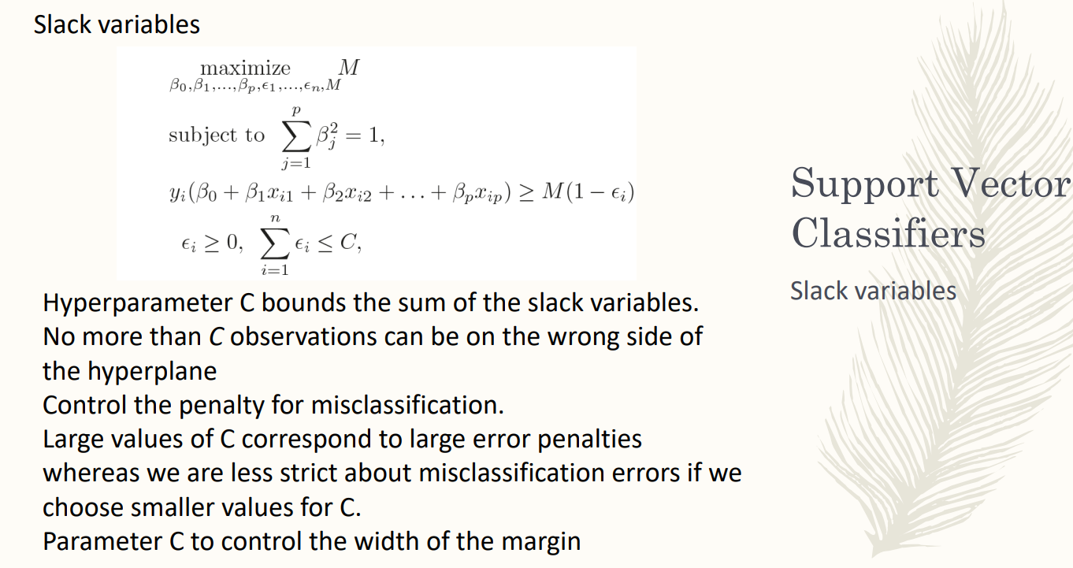

no more then C observation can be on the wrong side

the parameter control the weight of the margin

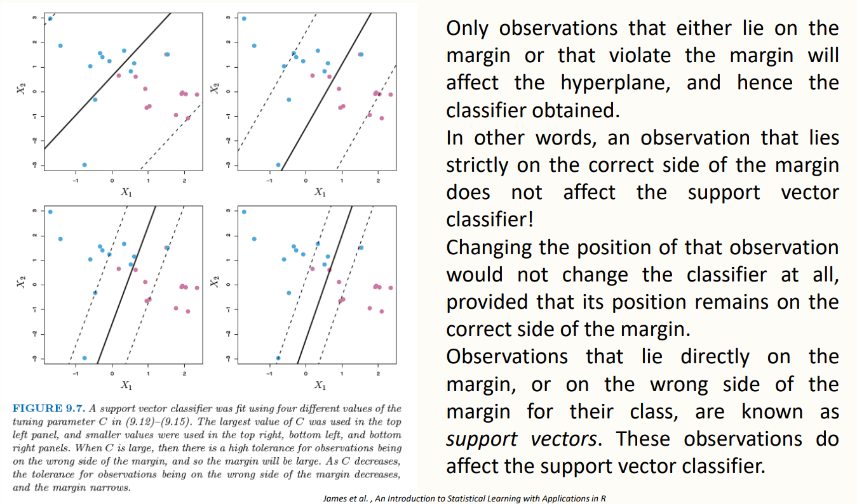

we can control how much larger the margin is.

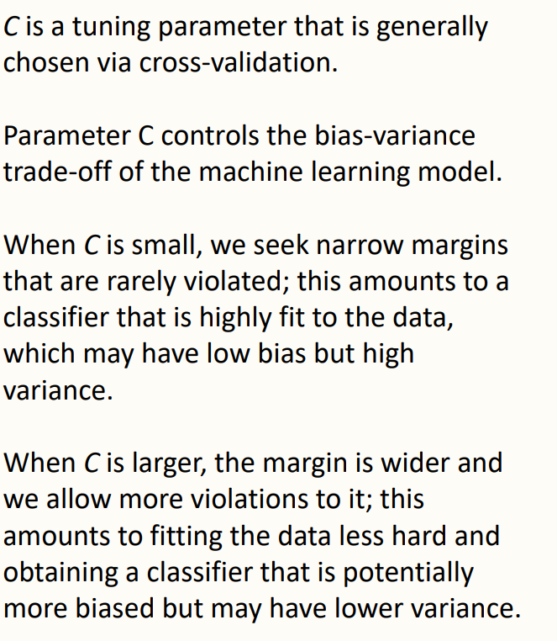

C larger

fitting the data less hard higher biases and lower variance

